**CT 310 CompTech LLC**

Romeo Casiano, King Awhaetoma, Emmaline Mercer, Trey Coon, Jaden Howard, Nathan Foster

Professor: Joel Wiredu

December 12, 2024

**Contents**

Memo ……….......………........……………........……………........……………........………….……. 3

Plan ...……………………………………………………………………….……......………….……. 4

Group Contributions ……………………………………………………………….………….4

Devices and Costs ……………………………………………………………….…………….5

Cabling ……………………………………………………………….………….…………….5

Budget ……………………………………………………………….………….…………….5

Explanation of Services ……………………………………………………………….……………….5

Conclusion ……………………………………………………………….………….…………………5

Network Topology ...……………………………………………………………………….……......... 9

Appendix A: Network Topology ............................................................................................................ 10

Appendix B: IP Address Design ............................................................................................................. 11

Appendix C: Physical Topology ............................................................................................................. 13

**Memo**

The CompTech LLC has created a branch in Muncie, Indiana. They have requested the services of our company to implement a network infrastructure to grow their business presence. They currently employ 168 people within their business, and they need each of those employees to be able to access the Muncie branch network as well as the main branch network. They currently have the following technologies at their disposal: 5 servers, 6 printers, the required PCs for each employee, and IP phones.

As a company, we will implement the following steps to address the needs of the CompTech LLC:

* The CompTech LLC requires a secure wireless network that clients can access to utilize their available resources without accessing private information, and they also desired a guest wireless network.
* All employees will be a part of their respective VLANs depending on their department: Marketing and Sales, Accounting and Financial Services, IT Infrastructure Management, Programmers, or Process Analyst and Quality Management.
* Finally, they needed a Management VLAN controlled by four IT and two Programmer employees who would be responsible for the new network management.
* These requirements will be outlined in the topology so that CompTech LLC’s needs can be easily implemented.

**Plan**

The project plan will be following these steps to completion:

* Create an IP scheme for each department so that they are all included in their own subnets.
* Create a network topology representation of the CompTech LLC subnets.
* Configure VLANs for each department, as well as a Management VLAN.
* Configure basic security on both the router and the switches in the subnets by accomplishing the following:
  + Encrypting passwords.
  + Setting minimum password lengths.
  + Enable logging synchronous on console and Telnet lines.
  + Creating a warning Banner for unauthorized access.
  + Disable DNS lookup.
* Configure the end devices:
  + Printers, PCs, IP Phones, etc.
* Group contributions:
  + Romeo Casiano: logical topology and subnet
  + King Awhaetoma: logical topology and subnet
  + Emmaline Mercer: Project Report and Presentation
  + Nathan Foster: technology costs and labor costs
  + Jaden Howard: physical topology
  + Trey Coon: explanation of services

**Budget and Costs**

|  |  |  |  |  |
| --- | --- | --- | --- | --- |
| Hardware/Vendor | Vendor | Quantity | Price Per Unit | Total Cost |
| 37u Rack | SysRacks | 14 | 829.99 | $11,619.86 |
| Catalyst 8300 1N1S-4T2X Router | Walmart | 2 | 5,041 | $10.082 |
| ICC ICMPP04860 Patch Panel | Beach Audio | 7 | 144.22 | $1,009.54 |
| Faceplates 2 port Ethernet Wall Plate | Walmart | 150 | 10.11 | $1,516.50 |
| Premiertek CAT6-Cat6 Cable 1000ft | Amazon | 7 | 273 | $1,911 |
| Cat6 connector gold plated ethernet pass through plug (100pack) | Amazon | 3 | 21.36 | $64.08 |
| Cisco N9K X9732C-EX Nexus 9500 Switch | Walmart | 5 | 12750 | $6,350 |
| Navepoint 15U wall mount server cabinet | FS.com | 5 | 292.96 | $1,464.80 |
| Cisco Catalyst 9115AXI-EWC-B Wireless Access Point | Amazon | 10 | 772.5 | $10,815.00 |
| Labor | N/A | 160 hours | 6 *$75 per hour | $72,000.00 |
| Total |  |  |  | $106,760.32 |

* + 2 Routers
    - $5,041 each
  + 5 Switches
    - $1,270 each
  + 10 Cisco C9115AXI-EWC-B Catalyst 9115AXI Access Points
    - $682 for a 5 pack
  + Cabling Cat6a
    - $273 for 1000ft
  + Labor Cost x6
    - $75 per hour
  + Total Cost:
    - $18,519
* Cabling type:
  + Cat6a ethernet cable
* Budget:
  + $106,760.32

### Explanation of Services in the Network Design

The network design for CompTech LLC integrates a suite of essential services that ensure secure, efficient, and scalable operations while meeting the organization’s specific needs. Each service has been carefully implemented to align with industry standards and optimize functionality for the new branch office.

The Dynamic Host Configuration Protocol (DHCP) service automates the assignment of IP addresses to devices across the network. By centralizing IP address allocation, DHCP reduces administrative overhead and prevents conflicts caused by manual IP configurations. Each VLAN is assigned its own DHCP scope, ensuring that devices within different departments receive addresses from their designated subnets. This organization enhances security, simplifies management, and ensures efficient resource allocation.

The Domain Name System (DNS) service resolves human-readable domain names into machine-readable IP addresses, enabling seamless connectivity between devices and external resources. In the CompTech network, DNS ensures that employees can access internal and external resources without memorizing complex numerical IP addresses, thereby improving productivity and reducing the likelihood of errors.

To safeguard the network’s integrity, Access Control Lists (ACLs) are implemented on routers to regulate traffic flow between VLANs and restrict unauthorized access. ACLs ensure that sensitive departmental resources remain isolated while allowing necessary communication. For example, IT administrators have exclusive access to the management VLAN, while other employees are restricted based on their roles and permissions.

Wireless connectivity is supported by a robust setup of Wireless Access Points (WAPs) configured with multiple Service Set Identifiers (SSIDs). Employee traffic is segmented from guest and client traffic, with encryption protocols such as WPA3 ensuring secure communication. The guest network operates on a completely isolated VLAN, providing access to the internet without exposing internal resources. This segmentation enhances overall security while maintaining a seamless user experience for visitors.

**CONCLUSION/ HOW COMPTECH NEEDS ARE MET**

**1. Employee Connectivity**

Need: Provide 168 employees with access to the company’s network and IT resources.

Solution: The network design ensures that each of the 168 employees is provided with seamless access to CompTech’s IT resources. Every employee is assigned a dedicated computer and IP phone connected to departmental VLANs. Network switches are strategically deployed on each floor, with Intermediate Distribution Frames (IDFs) placed on all seven floors and a Main Distribution Frame (MDF) located on the first floor. This structure enhances connectivity by reducing network latency and ensuring fast, reliable access to company resources. Additionally, the use of high-speed network switches guarantees smooth data transmission across all floors.

**2. Guest and Client Wireless Access**

Need: Allow guests and clients to access a secure wireless network.

Solution: To provide secure wireless access for guests and clients, a separate guest VLAN has been established. This VLAN ensures that guest traffic is isolated from internal network traffic, protecting sensitive company data. Wireless Access Points (WAPs) are strategically placed on all seven floors to ensure consistent and uninterrupted Wi-Fi coverage throughout the building. Security protocols such as WPA3 encryption and guest authentication controls are employed to safeguard access, while bandwidth restrictions are enforced to prioritize employee traffic over guest traffic.

**3. Departmental Segmentation and VLANs**

Need: Ensure network segmentation by department for security and efficiency.

Solution: The network design employs VLAN segmentation to group employees by department, allowing for efficient traffic management and enhanced security. Each department, including Marketing, Sales, Accounting, IT, Programmers, and Process Analysts, is assigned its own VLAN. This logical segmentation isolates network traffic, reducing congestion and minimizing the impact of potential network issues. It also provides a higher level of security by limiting cross-departmental traffic, ensuring that sensitive data is only accessible to authorized personnel.

**4. Data Center and Management VLAN**

Need: Provide remote access for managing network devices.

Solution: A dedicated management VLAN is created to give IT staff and programmers remote access to network devices. This VLAN is isolated from other network traffic, providing a secure environment for device administration and troubleshooting. The four IT staff and two programmers located on the third floor are responsible for managing the data center. The management VLAN allows these individuals to remotely access and configure network devices, ensuring quick response times for system updates, maintenance, and issue resolution.

**5. Wireless Coverage and Connectivity**

Need: Ensure full wireless connectivity on all seven floors.

Solution: Wireless connectivity is established throughout the building by installing Wireless Access Points (WAPs) on every floor. These access points provide comprehensive wireless coverage, enabling employees, guests, and clients to remain connected regardless of their location. Special attention is given to high-traffic areas such as conference rooms and collaborative spaces, which are equipped with enhanced WAPs to support multiple simultaneous connections. The strategic placement of access points ensures a strong signal throughout all 13,824 square feet on each floor, with no dead zones.

**6. Secure, Scalable, and Future-Proof Network**

Need: Build a secure, scalable, and future-ready network infrastructure.

Solution: The network is designed to be secure, scalable, and adaptable to future business needs. Security measures, such as VLAN segmentation, WPA3 encryption, and access control protocols, protect the network from unauthorized access. The use of Cat6 or Cat6a cabling allows for higher bandwidth and faster speeds, accommodating future advancements in technology. The modular design of the network infrastructure makes it easy to scale, enabling the addition of more devices, users, or services without requiring a complete redesign. This approach ensures that CompTech’s network is prepared for future growth and technological evolution.

**7. Logical and Physical Topologies**

Need: Provide a visual and technical representation of the network layout.

Solution: Logical and physical topology diagrams are created to visualize the network’s structure and layout. The logical topology illustrates the relationships between network devices, VLANs, and IP address assignments, while the physical topology highlights the physical placement of network devices, switches, routers, and cabling across all seven floors. These diagrams serve as valuable reference tools for network implementation, maintenance, and troubleshooting, ensuring clarity and precision in network configuration.

**Network Topology**

A network topology is visual arrangement of all nodes and connections within a network. It is commonly representative of both the physical and the logical versions. The nodes within this specific topology include one router, two switches, and four endpoints. Each node relates to its respective connection cable, an ethernet connection between the switches and router and a copper crossover connection between the switches and endpoint devices. The network is configured through the CLI of the switches and routers, and the IP configuration within the PCs. This will allow for connections between all devices amongst the networks. To view the network topology, please refer to **Appendix A: Network Topology**

**IP Address Design**

An IP address is, also known as an Internet Protocol address, is a unique set of numbers assigned to every device connected to the internet as a way of identifying that specific device. It works similarly to how athletes wear numbers on their respective jerseys so that they can be more easily identified. An IP address design is needed to properly assign addresses to devices so that the least number of addresses are assigned, which helps prevent wasting addresses. To do this properly, a VLSM, short for variable length subnet mask, is utilized; this is a networking technique that divides an IP network into subnets based on how many hosts are in a subnet, and it provides a different subnet mask for each host. To view the IP addressing scheme, please refer to **Appendix B: IP Address Design.**

**Appendix A: Network Topology**

**Visual Look:**

In the screenshot below, you can see an overview of the design and layout we all decided to go with:

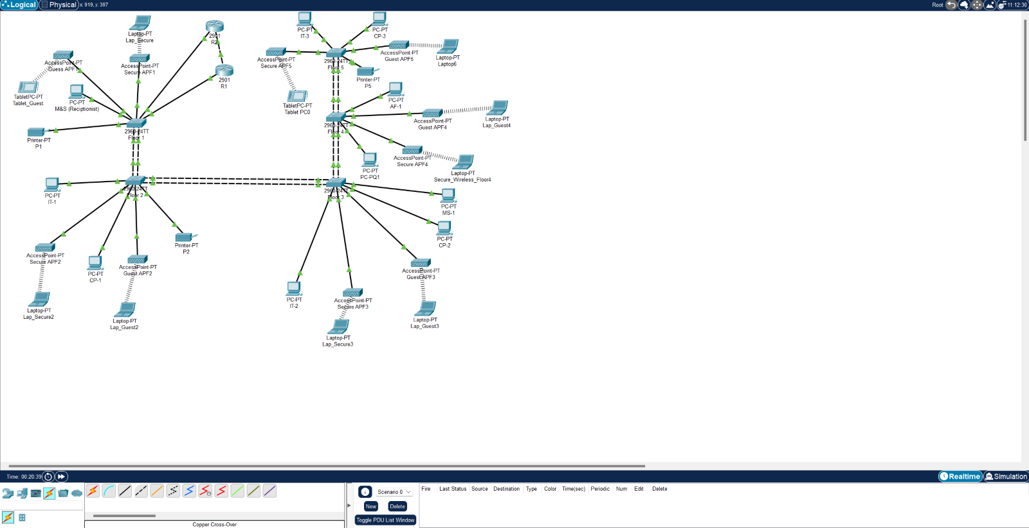

**Devices Used:**

* 5 2960-24TT
* 2 2901 Routers
* 10 Access Points
* Copper Cross-Over and Copper Straight Through Cables
* 23 End Devices

**Process for the Network:**

* Implementing EtherChannel throughout the Switches
* Configuring the Router’s
* Creating a DHCP Pool
* Creating VLANS and Implementing VLAN Trunking
* Assigning End Devices to their Proper VLANS
* Configure and Setup Access Points for Wireless Devcies
* Test Connection

**Network Simulation:**

* Showcase the Network Topology in Packet Tracer

**Challenges/Struggles:**

* Design
* Confused on the Project as a Whole
* Overwhelmed
* Connecting Devices to Different Vlans
* Subnetting
* Too Complex

**Takeaways/What I Learned:**

* Importance of Communication
* Using Resources to your Advantage
* Simplicity is better than Complexity
* Discipline
* Consistency
* Self-Learning

**Appendix B: IP Address Design**

**Subnetting:**

* Went with /24 design
* Capable of up to 254 usable devices

**Visual Look:**

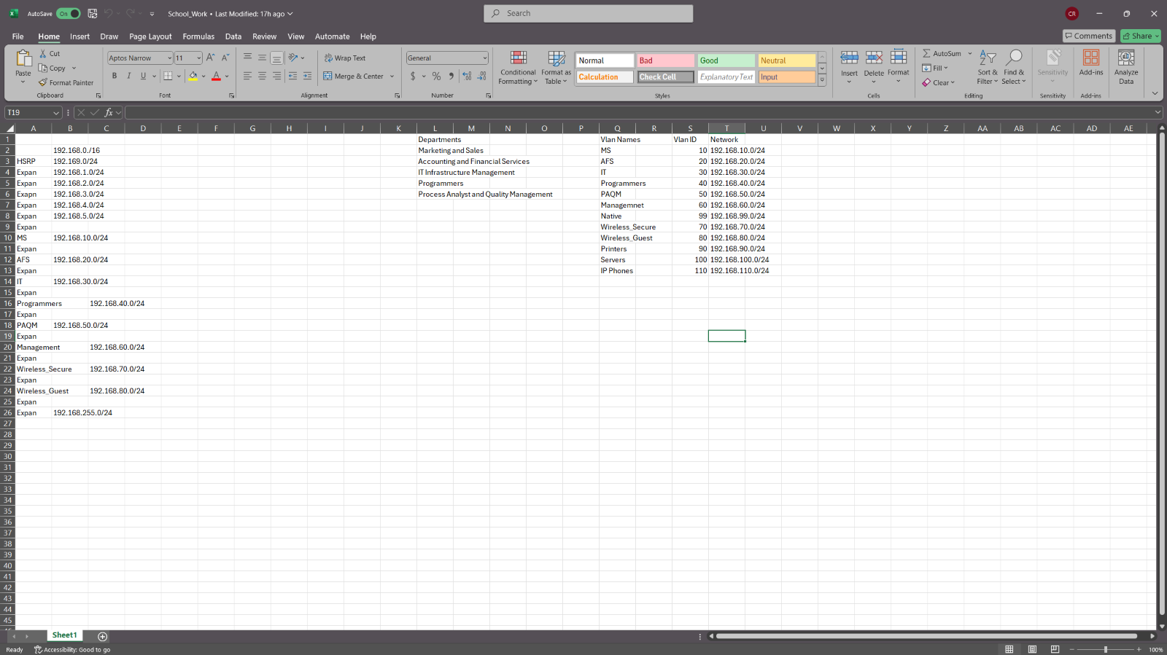

**Challenges/Struggles:**

* Subnetting in General
* How to Start

**Takeaways/What I Learned:**

* Importance of Communication
* Using Resources to your Advantage
* Simplicity is better than Complexity
* Discipline
* Consistency
* Self-Learning

**Appendix C: Physical Topology**

**Floor 1**

Floor 2

Floor 3

Floor 4

Floor 5

All Floors

